LAB 1

**Objectives of Lab 1**

1. Finalize project teams
2. Complete the process of project topic selection
3. Develop the business case for your project – analysis and justification
4. Create an Abstract describing your project (~150 words)
5. Project team organization activities

* Selection of project manager
* Define (high level) roles for team members
* Update Project team profile

**Development of the Business Case**

As per the discussion in the Week 2 lecture, your business case (analysis and justification) should include the following elements:

1. Incentive(s) to create your product – is there a profit opportunity and a public demand for this product? Describe the target audience who would benefit from your product. Is there an individual challenge associated with this effort?
2. Cost / benefit analysis – identify components of the project (personnel and other resources) which are likely to require funding (include the project team members' time and effort). Also, describe the (high level) benefits that people could derive from using this product. Be sure to categorize benefits as “hard” or “soft”, as discussed in the lecture.

First, conduct a team discussion on the business case. Then, complete the brief Project Abstract (~150 words) detailing the project posted in LEARN.

The following items should be included:

1. Short summary of the project
2. Motivation (business justification)
3. Anticipated challenges (technical and other)
4. Major tasks envisioned
5. Final deliverables

Your Instructors will review your Abstracts and discuss the recommendations (official OK to proceed or recommended revisions) at the start of lab in week 4. This review / decision is intended to (early in the process) catch and filter out ideas which may be infeasible based on this level of description. This is the first of 2 project approval gates (the second coming between weeks 6 and 7, after your formal Project Proposal has been created and presented during the Requirements phase).

**Selection of Team Project Manager**

Since project related decisions are already being considered, this is an appropriate time to begin the process of team organization. An important first step is to designate one team member as the overall project manager (PM).

**Roles / responsibilities of the project manager include:**

1. Development the work plan and schedule, including updates as necessary
2. Monitor project status on an on-going basis and communicate to stakeholders (in this case your instructor and TA) on a timely basis.
3. Organize and coordinate the weekly team “huddles”, including creating an agenda for each meeting

The project manager may delegate any of these responsibilities to other members of the team as per his / her discretion.

It is key that the project manager be ultimately responsible for the execution of the project, but all team members are equal owners of the outcome. Therefore, it is critical that the PM be totally respectful of the other team members (as opposed to dictating the process) and serve as an enabler to the team. An important aspect of this role is to ensure that all members are fully utilized throughout the entire project and are assigned tasks that best suit their skills and preferences.

**Roles and responsibilities of (non PM) team members may include:**

1. business designer
2. technical designer
3. application developer
4. data analyst
5. planner and scheduler – either PM or delegated
6. scribe – status reporting, technical and other project documents, etc.
7. Other roles as dictated by the nature of the project

Lab 2 Bitbucket Team Repository

In this lab, you will setup a Bitbucket repository for your project team. Note that individual assignments for his course will be handed in using your personal Bitbucket repository, but all team assignments and deliverables must be placed in your team repository for grading purposes. If your team does not create and use a Bitbucket team repository, you will not receive any credit for your project assignments.

**Part I. Creating a Repository for your Team**

1. First there are a number of different roles that are required for a successful team. At this point you need to identify the person on your team that is the project manager and the support manager. Other team members can be developers and need to identify their development skills. The support manager will be the team member that will become versed using the tools introduced in CI102. The support manager will also be the owner of the repository in Bitbucket that you will use for delivering all of your team assignments.
2. Choose the support manager on your team. At this point you should have been assigned a 2 digit team number.

The **support manager** will go to [www.bitbucket](http://www.bitbucket) to create a repository for your team named “Team*nn*-Drexel-17” where *nn* is your assigned team number. To create a repository pull down on the Create Repository menu and click on the Create team button as depicted below.

Access level: make sure it is a private repository

Repository type: Git

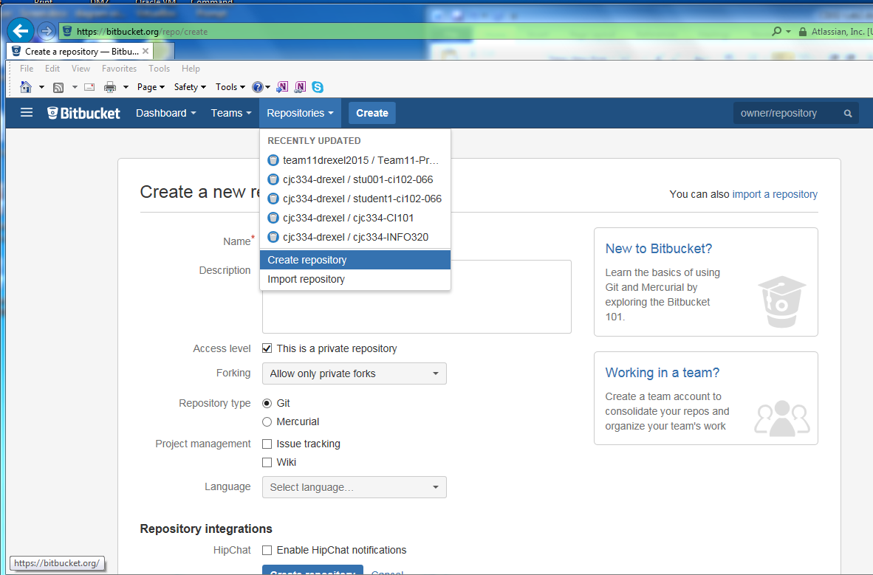

1. Next, the tools manager will need to clone the repository on their computer. Use the “Clone in SourceTree button” presented to you in the Repository setup screen. This will invoke SourceTree; it should bring up a window similar to the one depicted below:

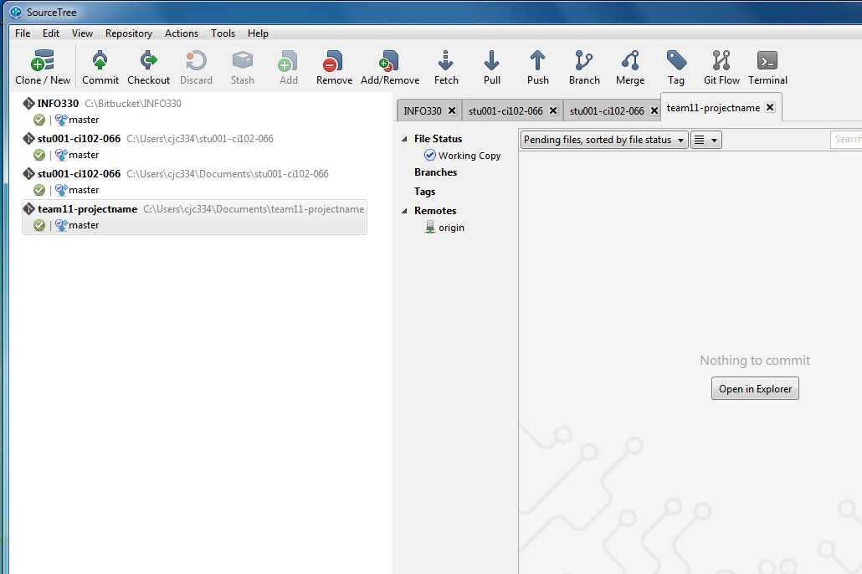

1. Now, let’s add a file to your repository. In SourceTree, click the toolbar button at the top called something like “Show in Explorer” or “Show in Finder” depending on your operating system.
2. Next create a text file named first-project-file.txt with some text in it and save the file to that folder.
3. Move your pointer to the top of the Sourcetree window and click on “Actions” to reveal the Actions pull down menu. Choose “Open in terminal”, and use the git add, git commit, git config –global push.default simple followed by the git push commands to put an initial file in your repository.

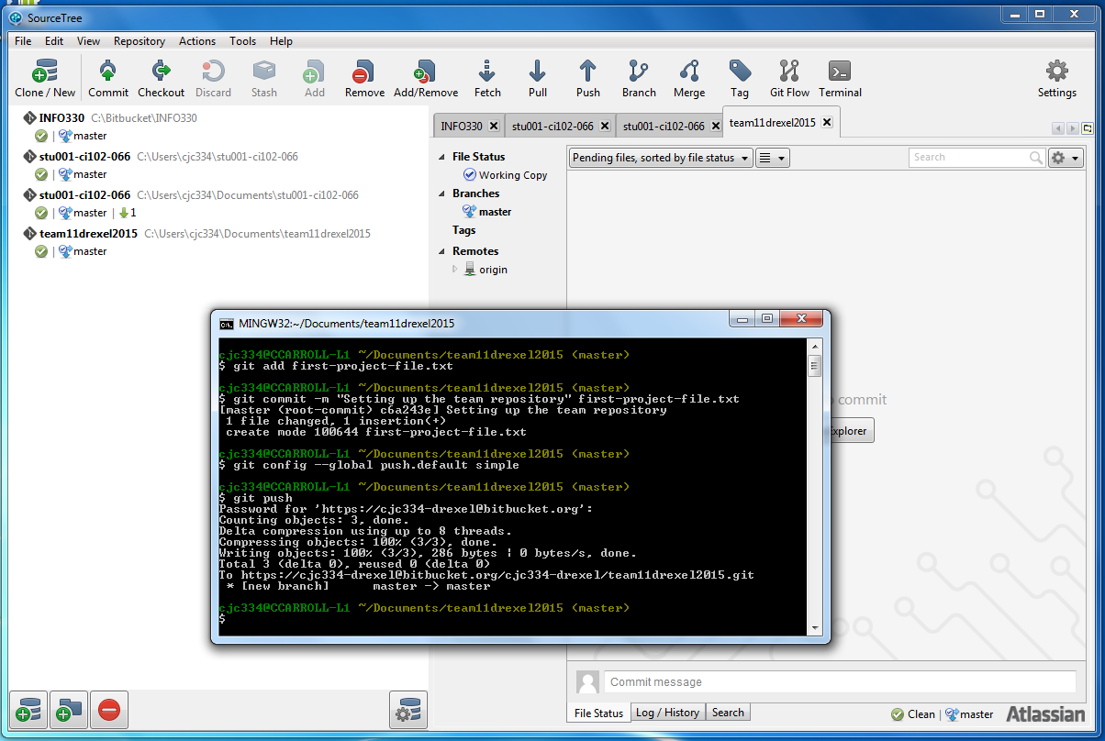

1. You should be prompted for your password. Type in the password to your Bitbucket account.
2. Go to a web browser and connect to [www.bitbucket.com](http://www.bitbucket.com); log into your account, and check to make sure your text file made it into the team repository.
3. Now that you have successfully placed a text file in your repository, you will need to perform a few more tasks to make sure that all the instructors and teaching assistants can gain access to your repository.
4. In the top-middle of the web page, you should see a link in this format:

git@bitbucket.org:*stu001-drexel*/ Team*nn*-Drexel-17.git

where *stu001-drexel* is the Bitbucket id for the tools manager on your team and

*nn* represents your team number and

the word “SSH” in a button next to it. In order to automate accessing your repository, copy the ssh link and paste this line into your file named first-project-file.txt located on your laptop.

**Be sure this is the SSH link and not the HTTPS link – the link should not begin with https**.

1. Now open a terminal window in SourceTree on your laptop and perform the same steps for pushing your updated first-project-file.txt to your Bitbucket repository. These are:

$ git add first-project-file.txt

$ git commit –m “Updated file from lab 2” first-project-file.txt

$ git push

1. Next, provide access to the team repository to all team members.

Remember once you have put some ”bits” in your repository, use the “Share” button to add access to other Bitbucket accounts.

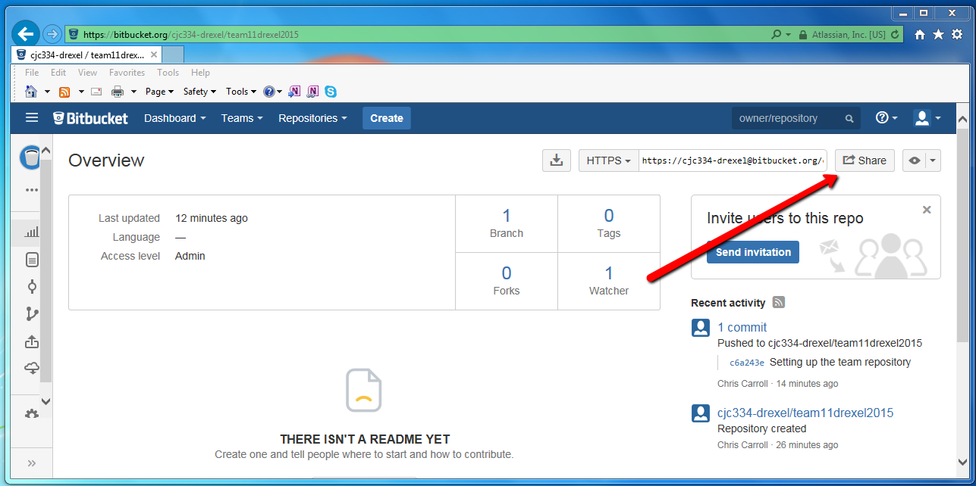

1. Have each team member log into Bitbucket and clone the team repository to their computer.
2. Enable all of the CI102 instructors and TA’s to have read/write access to your team repository. These should be provided to you during this lab session.

**What to Turn In**

Complete the CI102 Project Abstract document, (posted in LEARN), and push this Word document to your ***team*** Bitbucket repository. Make sure that all team members, TA’s and instructors have access to your team repository.